SplitEase

Multi-Currency Expense Splitter



INTRODUCTION
SplitEase is a comprehensive, full-stack web application designed to simplify the management of shared expenses among groups of people. Built on the MERN stack (MongoDB, Express.js, React.js, and Node.js), SplitEase provides a seamless platform for creating expense groups, adding members, tracking shared costs, and settling balances — all with real-time notifications and live multi-currency support.

In today's interconnected world, people frequently share expenses during travel, events, shared housing, and group activities. Managing who owes what to whom — especially across different currencies — is a common pain point. SplitEase addresses this challenge by providing an intuitive, feature-rich platform that automates complex split calculations and keeps everyone informed in real time.

Scenario Based Case Study
Meet Sarah, a university student who frequently travels and socializes with a diverse group of friends from different countries. Managing shared expenses during trips, group dinners, and events has always been a headache — especially when different currencies are involved.

Sarah discovers SplitEase, a comprehensive web application designed to streamline group expense management. Intrigued by its features, Sarah decides to explore how SplitEase can help her and her friends manage their shared costs effortlessly.

- User Registration and Authentication: Sarah registers an account on SplitEase, providing her details and preferred default currency. She logs in securely using JWT-based authentication, ensuring her data remains private and secure.
- Group Management: Sarah creates an expense group for her upcoming trip to Paris. She invites friends by email, and they all join the group with their respective accounts.
- Expense Tracking: Throughout the trip, different members pay for different things. Sarah adds a hotel expense of EUR 450 paid by her. Her friend adds a restaurant bill of GBP 80. SplitEase automatically converts all amounts to the group's base currency for consistent balance tracking.
- Split Calculations: SplitEase offers three split modes — equal, percentage-based, and custom amounts — giving the group full flexibility in how expenses are divided.
- Real-Time Notifications: When her friend settles their share, Sarah receives an instant notification in the app without needing to refresh the page, powered by Socket.io.
- Analytics: Sarah can view spending trends, see who has paid the most, and track settlement history — all through beautiful charts and a dedicated analytics dashboard.

Thanks to SplitEase, Sarah and her friends can focus on enjoying their trip rather than worrying about who owes what. SplitEase has become an indispensable tool for managing their group finances with ease and transparency.
SYSTEM REQUIREMENTS

Software Requirements
These are the essential tools and platforms required to develop, test, and run the application efficiently.

Software | Description / Purpose
Operating System | Windows 10/11, macOS, or Linux — supports cross-platform development
Node.js (v18+) | Provides the JavaScript runtime environment for server-side logic and API routing
npm (v8+) | Package manager used to install and manage dependencies for both client and server
React.js + Vite | Frontend library for building dynamic, component-based user interfaces with fast HMR
Express.js | Lightweight backend framework for building RESTful APIs
MongoDB | NoSQL database for storing users, groups, and expense data as JSON documents
Mongoose | ODM (Object Document Mapper) for schema design and MongoDB interaction
Socket.io | Enables real-time bidirectional communication for instant notifications
Git + Git Bash | Version control and terminal for cross-platform command execution
VS Code | Preferred code editor with integrated terminal and Git support
MongoDB Compass | GUI tool for viewing and managing the local MongoDB database
Thunder Client | VS Code extension for API testing (alternative to Postman)
ExchangeRate-API | External REST API providing live exchange rates for 170+ currencies

Hardware Requirements
Component | Minimum Specification
Processor | Intel Core i5 (8th Gen+) / AMD Ryzen 5 or better
RAM | Minimum 8 GB (16 GB recommended for running both dev servers simultaneously)
Storage | At least 2 GB free space for packages, MongoDB data, and project files
Display | 1366x768 or higher for optimal coding and application layout experience
Internet | Required for ExchangeRate API calls and MongoDB Atlas connectivity

KEY FEATURES
SplitEase provides a comprehensive set of features designed to make group expense management effortless and transparent.

- User Registration and Authentication: Secure account creation with JWT-based authentication and bcrypt password hashing. Users can register with a preferred default currency and manage their profile settings.
- Group Management: Create named expense groups with a base currency and description. Add members by email address. Multiple members can be part of multiple groups simultaneously. Group creators can delete groups they own.
- Multi-Currency Expense Tracking: Add expenses in any of 7 supported currencies (USD, EUR, GBP, INR, JPY, AUD, CAD). All balances are automatically converted to the group's base currency using live exchange rates fetched from ExchangeRate-API with a 1-hour cache.
- Flexible Split Modes: Three ways to divide expenses — Equal Split (divided evenly among all members), Percentage Split (each member assigned a custom percentage), and Custom Amount (manually specify how much each person owes).
- Balance Tracking: Real-time calculation of how much each member is owed or owes, with net balance displayed. Balances are shown in the group's base currency with automatic conversion.
- Expense Settlement: Members can mark their share as settled with a single click. Settlement status is tracked per split, showing Pending or Settled badges.
- Real-Time Notifications: Powered by Socket.io, when a member settles their share the payer receives an instant notification without needing to refresh the page.
- Analytics Dashboard: Visualize spending trends over time with line graphs, see spending breakdown by group member with doughnut charts, and view animated progress bars showing group-by-group spending totals.
- Settlement History: A dedicated page showing all settled expenses across all groups, filterable by All, I Paid, or I Received, with summary statistics.
- Search: Search for expenses across all groups simultaneously by description, currency, or member name.
- Profile Management: Update name, email, and default currency. Change password securely with current password verification.
- Dark Mode: Full dark mode support across all pages, persisted to localStorage, toggled via the navbar.
- Animated UI: Smooth page transitions, skeleton loading screens, animated expense cards, hover effects, and floating background animations using Framer Motion.

PROJECT ARCHITECTURE

Technical Architecture
SplitEase follows a client-server architecture where the React frontend (client) communicates with the Express.js backend (server) through a RESTful API over HTTP. Socket.io adds a persistent WebSocket layer for real-time communication. The backend interacts with a MongoDB database through Mongoose ODM for all data persistence.

The flow of a typical request through the system:

Step | Layer | Action | Technology
1 | Frontend | User performs an action (e.g., adds expense) in the React UI | React + Axios
2 | Network | Axios sends HTTP request with JWT in Authorization header | HTTP/HTTPS
3 | Middleware | auth.middleware.js verifies JWT token and attaches user to request | Express + JWT
4 | Router | Express routes request to the appropriate controller function | Express Router
5 | Controller | Business logic executes: validates input, processes data, calls model | Express Controller
6 | Model | Mongoose model performs database operation (CRUD) on MongoDB | Mongoose + MongoDB
7 | Response | Controller sends JSON response back to frontend | Express Response
8 | Frontend | React updates state, UI re-renders with new data | React useState
9 | Real-time | For settlements: Socket.io emits notification to payer's room | Socket.io

Project Structure
Backend Structure (server/)
File / Folder | Description
src/server.js | Entry point — creates HTTP server, connects Socket.io, connects to MongoDB, starts Express
src/app.js | Express app setup — registers middleware (cors, json) and mounts all routes
src/socket.js | Socket.io initialization — manages user rooms for targeted real-time notifications
src/models/User.model.js | Mongoose schema for users: name, email, password (hashed), defaultCurrency
src/models/Group.model.js | Mongoose schema for groups: name, description, baseCurrency, createdBy, members[]
src/models/Expense.model.js | Mongoose schema for expenses with nested splits sub-schema
src/controllers/auth.controller.js | Handles register, login, getMe, updateProfile, changePassword
src/controllers/group.controller.js | Handles createGroup, getGroups, getGroupById, addMember, deleteGroup
src/controllers/expense.controller.js | Handles createExpense, getExpensesByGroup, updateExpense, deleteExpense, settleExpense
src/controllers/currency.controller.js | Fetches live exchange rates with 1-hour cache, handles currency conversion
src/routes/auth.routes.js | API routes for /api/auth — with express-validator input validation
src/routes/group.routes.js | API routes for /api/groups — all protected by auth middleware
src/routes/expense.routes.js | API routes for /api/expenses — all protected by auth middleware
src/routes/currency.routes.js | API routes for /api/currency — rates and conversion endpoints
src/middleware/auth.middleware.js | JWT verification middleware — protects all private routes
src/utils/splitCalculator.js | Pure utility functions for equal, percentage, and custom split calculations
.env | Environment variables: PORT, MONGO_URI, JWT_SECRET, EXCHANGE_API_KEY

Frontend Structure (client/src/)
File / Folder | Description
pages/Login.jsx | Animated login page with floating emoji particles and glassmorphism card
pages/Register.jsx | Animated register page with password strength indicator and success animation
pages/Dashboard.jsx | Groups list with animated background, hover effects, and group creation modal
pages/GroupDetail.jsx | Full group view with expenses, balances, Line + Doughnut charts, split modals
pages/Analytics.jsx | Spending analytics with stat cards, line chart, doughnut chart, progress bars
pages/Profile.jsx | Profile management with tabs for personal info and password change
pages/SettlementHistory.jsx | All settled expenses across groups with filter tabs and summary stats
pages/Search.jsx | Cross-group expense search by description, currency, or member name
components/Navbar.jsx | Sticky navbar with professional icons, notification bell, profile dropdown, dark mode
components/PageWrapper.jsx | Framer Motion page transition wrapper with animated gradient background
components/Skeleton.jsx | Skeleton loading components for group cards and expense items
context/AuthContext.jsx | Global auth state — user data, login, register, logout with Socket.io integration
context/ThemeContext.jsx | Global dark mode state — persisted to localStorage, toggles Tailwind dark class
services/api.js | Axios instance with JWT interceptor — all API call functions
socket.js | Socket.io client — connects to backend WebSocket server

MVC PATTERN
SplitEase follows the Model-View-Controller (MVC) architectural pattern, a software design approach that separates an application into three interconnected layers. This separation allows for modularity, easier maintenance, and scalability.

Model Layer (Data Layer)
The Model layer is responsible for handling all data-related logic. This includes the definition of data schemas and the operations performed on the database using those schemas. The models are implemented using Mongoose, which provides a schema-based solution to model application data for MongoDB.

- User.model.js: Defines the user schema with fields for name (required, trimmed), email (required, unique, lowercase), password (required, bcrypt hashed), and defaultCurrency (defaults to USD). Uses timestamps for automatic createdAt and updatedAt fields.
- Group.model.js: Defines the group schema with name, description, baseCurrency, createdBy (ObjectId reference to User), and members (array of ObjectId references to Users).
- Expense.model.js: Defines a nested schema — the main expense schema contains group (ObjectId ref), paidBy (ObjectId ref), description, amount, currency, splitType (enum: equal/percentage/custom), and a splits array. Each split contains user (ObjectId ref), amount, currency, and settled (boolean, default false).

Controller Layer
The Controller layer acts as an intermediary between the routes (view) and the model. It receives incoming requests, processes input (including validation), calls the appropriate model methods, and returns a response to the client.

- auth.controller.js: Contains register (creates user with hashed password, returns JWT), login (verifies credentials, returns JWT), getMe (returns current user), updateProfile (updates user fields), and changePassword (verifies current password before hashing new one).
- group.controller.js: Contains createGroup (auto-adds creator as first member), getGroups (finds all groups where user is a member), getGroupById (with member check), addMember (finds user by email, prevents duplicates), and deleteGroup (creator-only authorization check).
- expense.controller.js: Contains createExpense (calls splitCalculator, saves with populated data), getExpensesByGroup, updateExpense, deleteExpense (payer-only), and settleExpense (marks current user's split as settled, emits Socket.io notification to payer).
- currency.controller.js: Implements getRates (with 1-hour in-memory cache to reduce API calls) and convertCurrency (real-time conversion between any two currencies).

View Layer (Routing Layer)
In the context of a backend REST API, the View is implemented as the routing layer where various endpoints are defined. These endpoints determine how the backend responds to different HTTP methods and invoke the appropriate controller functions.

Method | Endpoint | Controller Function | Auth Required
POST | /api/auth/register | register | No
POST | /api/auth/login | login | No
GET | /api/auth/me | getMe | Yes
PUT | /api/auth/profile | updateProfile | Yes
PUT | /api/auth/password | changePassword | Yes
GET | /api/groups | getGroups | Yes
POST | /api/groups | createGroup | Yes
GET | /api/groups/:id | getGroupById | Yes
POST | /api/groups/:id/members | addMember | Yes
DELETE | /api/groups/:id | deleteGroup | Yes
POST | /api/expenses | createExpense | Yes
GET | /api/expenses/group/:groupId | getExpensesByGroup | Yes
PUT | /api/expenses/:id | updateExpense | Yes
DELETE | /api/expenses/:id | deleteExpense | Yes
PUT | /api/expenses/:id/settle | settleExpense | Yes
GET | /api/currency/rates | getRates | Yes
POST | /api/currency/convert | convertCurrency | Yes

Advantages of Using MVC in This Project
- Separation of Concerns: Each layer has a clearly defined responsibility, improving readability and maintainability.
- Scalability: New features can be added easily by creating new routes, controllers, and models without touching existing code.
- Reusability: Logic in controllers and models can be reused across multiple parts of the application.
- Testability: Each layer can be tested independently, especially the controllers and utility functions like splitCalculator.
- Collaboration-Friendly: Multiple developers can work simultaneously on different layers without conflict.
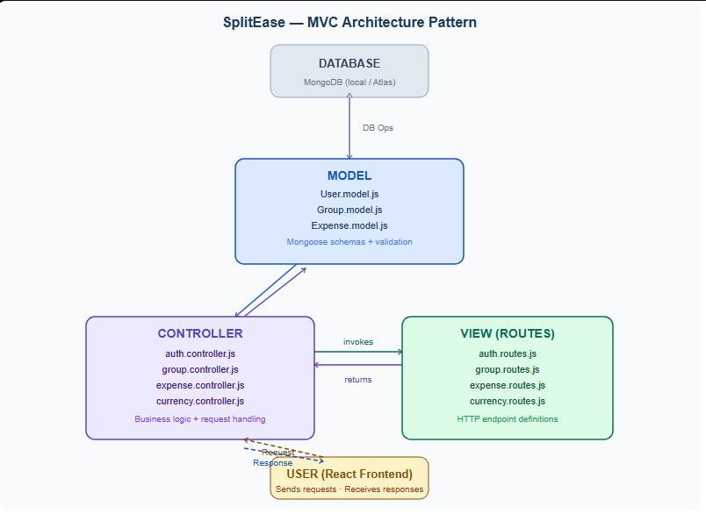

DATABASE SCHEMA (ER DIAGRAM)
The database schema for SplitEase represents three core entities and their relationships within the expense management system.

Entities and Attributes
1. User
Field | Type | Required | Notes
_id | ObjectId | Auto | Primary Key (auto-generated)
name | String | Yes | Trimmed, min 2 chars
email | String | Yes | Unique, lowercase, valid email format
password | String | Yes | bcrypt hashed, never stored plain text
defaultCurrency | String | No | Default: USD
createdAt / updatedAt | Date | Auto | Auto-managed by Mongoose timestamps

2. Group
Field | Type | Required | Notes
_id | ObjectId | Auto | Primary Key
name | String | Yes | Group display name
description | String | No | Optional group description
baseCurrency | String | No | Default: USD — used for balance display
createdBy | ObjectId (ref: User) | Yes | Foreign Key — references User._id
members | [ObjectId (ref: User)] | Yes | Array of Foreign Keys referencing User._id
createdAt / updatedAt | Date | Auto | Auto-managed timestamps

3. Expense
Field | Type | Required | Notes
_id | ObjectId | Auto | Primary Key
group | ObjectId (ref: Group) | Yes | Foreign Key — references Group._id
paidBy | ObjectId (ref: User) | Yes | Foreign Key — references User._id
description | String | Yes | Expense description (e.g., Hotel, Dinner)
amount | Number | Yes | Total expense amount
currency | String | Yes | Currency code (USD, EUR, GBP, etc.)
splitType | String (enum) | Yes | equal | percentage | custom
splits | [SplitSchema] | Yes | Array of individual member splits (see below)
date | Date | No | Default: Date.now
createdAt / updatedAt | Date | Auto | Auto-managed timestamps

3a. Split Sub-Schema (embedded in Expense)
Field | Type | Required | Notes
user | ObjectId (ref: User) | Yes | Which member owes this amount
amount | Number | Yes | Amount this member owes
currency | String | Yes | Currency of this split amount
settled | Boolean | No | Default: false. True when member settles

Relationships
- User to Group: One-to-Many — a user can create many groups (createdBy). Many-to-Many — a user can be a member of many groups and a group can have many members (members array).
- Group to Expense: One-to-Many — a group can have many expenses, each expense belongs to exactly one group.
- User to Expense: One-to-Many — a user can pay for many expenses (paidBy field). Many-to-Many — a user can appear in the splits of many expenses.

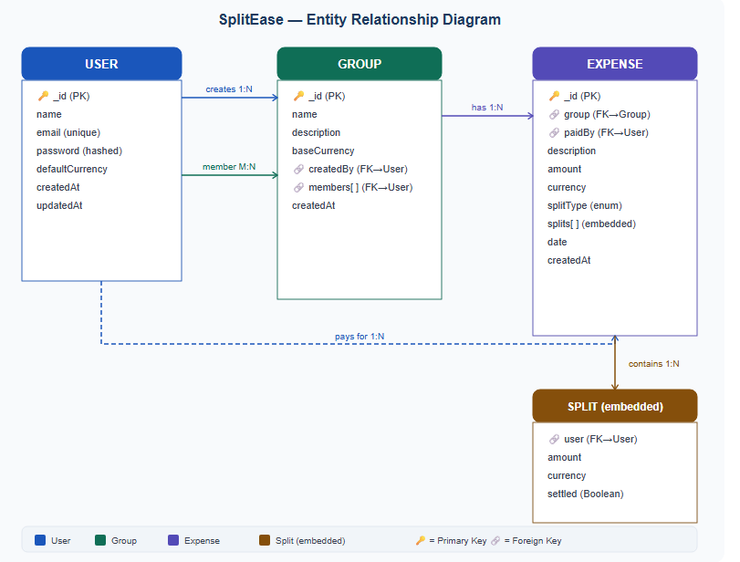

BACKEND DEVELOPMENT

Setup and Configuration
The backend is a Node.js application using Express.js. It is initialized with npm init -y and all dependencies are installed via npm. The entry point is src/server.js which creates an HTTP server, attaches Socket.io, connects to MongoDB, and starts listening on the configured port.

Dependencies Installed
Package | Version | Purpose
express | ^4.x | Web framework for building the REST API
mongoose | ^8.x | MongoDB ODM for schema design and DB operations
jsonwebtoken | ^9.x | JWT generation and verification for authentication
bcryptjs | ^2.x | Password hashing and comparison
cors | ^2.x | Cross-Origin Resource Sharing configuration
dotenv | ^16.x | Loading environment variables from .env file
axios | ^1.x | HTTP client for calling ExchangeRate-API
socket.io | ^4.x | WebSocket server for real-time notifications
express-validator | ^7.x | Input validation and sanitization middleware
nodemon (dev) | ^3.x | Auto-restart server on file changes during development

Authentication System
Authentication is implemented using JSON Web Tokens (JWT). When a user registers or logs in, the server generates a JWT signed with the JWT_SECRET from the .env file. The token contains the user's MongoDB _id as the payload and expires after 30 days.

The auth middleware (auth.middleware.js) is applied to all protected routes. It extracts the token from the Authorization header (Bearer token format), verifies it using jwt.verify(), fetches the user from MongoDB excluding the password field, and attaches the user object to req.user for use in controllers.

Split Calculator Logic
The splitCalculator.js utility contains the core business logic for dividing expenses:

- Equal Split: Total amount divided by number of members. Each member's share is rounded to 2 decimal places using parseFloat(splitAmount.toFixed(2)).
- Percentage Split: Each member is assigned a custom percentage. Their share is calculated as (amount * percentage) / 100. Percentages must sum to 100.
- Custom Split: Each member is manually assigned a specific amount. The system accepts these values directly without calculation.

Currency Caching
To avoid exceeding the ExchangeRate-API free tier limit of 1,500 requests per month, a simple in-memory cache is implemented. Two module-level variables store the cached rates object and the timestamp of the last fetch. On each request, if cached data exists and is less than 1 hour old (3,600,000 milliseconds), the cached data is returned immediately. Otherwise, a fresh API call is made, and the cache is updated.

FRONTEND DEVELOPMENT

Setup and Configuration
The frontend is a React application bootstrapped with Vite for fast development and hot module replacement. Tailwind CSS is configured with darkMode: 'class' to support the application's dark mode feature. The main entry point (main.jsx) wraps the entire application in ThemeProvider, AuthProvider, BrowserRouter, and ToastContainer from react-toastify.

Frontend Dependencies
Package | Purpose
react + react-dom | Core React library for building the UI component tree
vite + @vitejs/plugin-react | Build tool and development server with HMR
react-router-dom | Client-side routing for SPA navigation between pages
axios | HTTP client for making API requests to the Express backend
tailwindcss | Utility-first CSS framework for all styling
framer-motion | Animation library for page transitions, card animations, hover effects
chart.js + react-chartjs-2 | Charts: Line graphs for spending trends, Doughnut charts for member breakdown
react-toastify | Toast notification system for success/error feedback
react-icons | Professional Material Design icon library (MdDashboard, MdAnalytics, etc.)
socket.io-client | WebSocket client for receiving real-time notifications

State Management
Global state is managed using React's Context API with two custom contexts:

- AuthContext: Manages the authenticated user's data. On mount, it checks localStorage for a stored user object and rehydrates the state. It exposes login(), register(), and logout() functions. Login and register store the user + JWT to localStorage and connect the Socket.io client. Logout clears localStorage and disconnects the socket.
- ThemeContext: Manages dark mode state. On mount, it reads the darkMode value from localStorage. When toggled, it updates localStorage and adds/removes the 'dark' CSS class on document.documentElement to activate Tailwind's dark mode variants.

Routing
React Router DOM v6 is used for client-side navigation. Routes are defined in App.jsx using the Routes and Route components wrapped in AnimatePresence from Framer Motion for page transition animations. Protected routes redirect unauthenticated users to /login using the Navigate component. The isDashboard check on the root path removes the global background for the dashboard so its animated background is visible.

Real-Time Communication (Socket.io Client)
A Socket.io client instance is created in socket.js with autoConnect: false. When a user logs in, the socket connects and emits a 'join' event with the user's ID. The server uses this to add the socket to a room named after the user's ID. The Navbar component listens for 'notification' events and adds them to the notifications state, updating the bell badge count in real time. When the user logs out, the socket disconnects.

ROLES AND RESPONSIBILITIES

User
- Registration and Account Management: Users register with name, email, password, and default currency. They can update their profile and change their password through the Profile page.
- Group Creation and Management: Authenticated users can create expense groups, set a base currency, add members by email, and delete groups they created.
- Expense Management: Users add expenses to groups, specify the amount and currency, choose a split type, and can delete expenses they paid for.
- Settlement: Users settle their share of expenses by clicking 'Mark as settled', which triggers a real-time notification to the person who paid.
- Analytics and Reporting: Users can view their spending analytics, settlement history, and search for expenses across all their groups.

User Flow
Step | Action | Description
1 | Register / Login | User creates account or logs in with email and password
2 | Dashboard | View all groups, create new groups, delete owned groups
3 | Group Detail | View expenses, balances, charts; add members and expenses
4 | Add Expense | Enter description, amount, currency, split type; submit
5 | Settle | Click 'Mark as settled' — payer gets real-time notification
6 | Analytics | View spending trends, group breakdown charts, total statistics
7 | Search | Search for expenses across all groups simultaneously
8 | History | View all settled expenses filtered by All, I Paid, I Received
9 | Profile | Update personal info or change password
10 | Logout | Session cleared from localStorage, socket disconnected

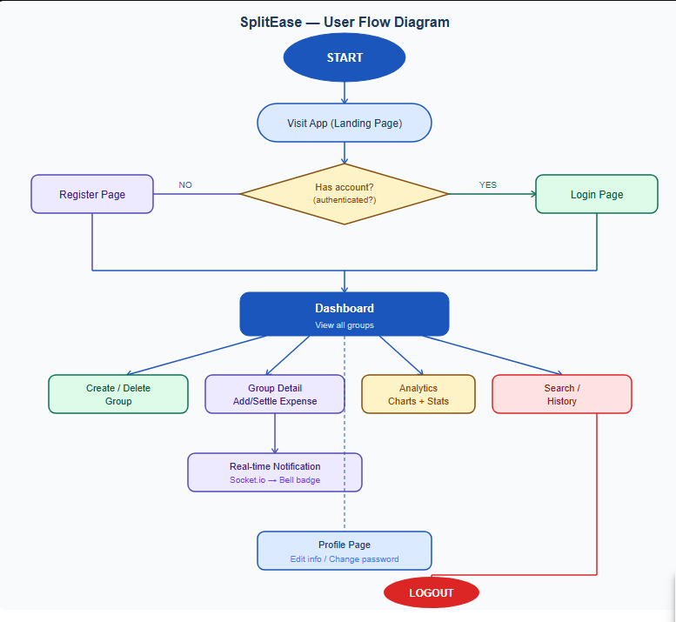

RECOMMENDED NPM PACKAGES

Frontend (UI & Utilities)
Package | Usage in SplitEase
axios | All API requests from React to Express backend with JWT header injection
react-router-dom | SPA routing: Login, Register, Dashboard, GroupDetail, Analytics, Profile, History, Search
tailwindcss | All styling including responsive layouts, dark mode variants, utility classes
react-icons | Professional Material Design icons in navbar, analytics page, settlement history
react-toastify | Success and error toast notifications for all CRUD operations
framer-motion | Page transitions, card slide-in animations, hover/tap effects on buttons
chart.js | Line chart (spending over time), Doughnut chart (spending by member)
react-chartjs-2 | React wrapper for Chart.js enabling declarative chart components
socket.io-client | Real-time notification reception from the backend Socket.io server

Backend Packages
Package | Usage in SplitEase
express | Core web framework — routing, middleware, request/response handling
mongoose | MongoDB ODM — User, Group, Expense models with validation and populate()
jsonwebtoken | JWT generation on login/register, verification in auth middleware
bcryptjs | Password hashing on registration, comparison on login
cors | Enables cross-origin requests from React (localhost:5173) to Express (localhost:5000)
dotenv | Loads MONGO_URI, JWT_SECRET, EXCHANGE_API_KEY from .env file
axios | Server-side HTTP calls to ExchangeRate-API for live currency rates
socket.io | WebSocket server — manages user rooms for targeted real-time notifications
express-validator | Input validation on auth routes — email format, password length, name requirements
nodemon | Dev dependency — auto-restarts server on file save during development

OUTPUT SCREENSHOTS
The following section describes the key screens of the SplitEase application.

Login Page
The login page features an animated blue-to-indigo gradient background with floating money emojis that rise from the bottom of the screen. A glassmorphism card sits in the center with the SplitEase logo (with a pulsing ring animation), tagline, email and password fields, and a white login button. The 'Split expenses, not friendships' tagline is displayed below the logo.
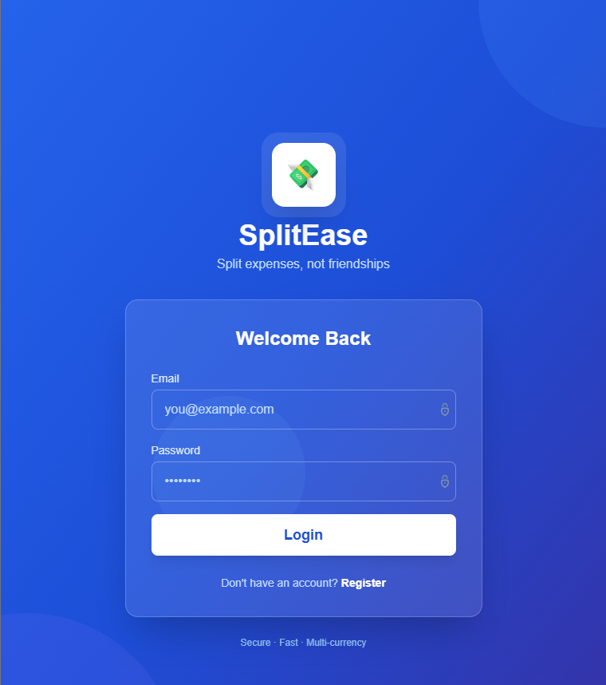

Register Page
The register page mirrors the login page's style with a purple-to-indigo gradient. It includes a password strength indicator with colored bars that update in real time as the user types. On successful registration, a success animation shows a celebration emoji before redirecting to the dashboard.
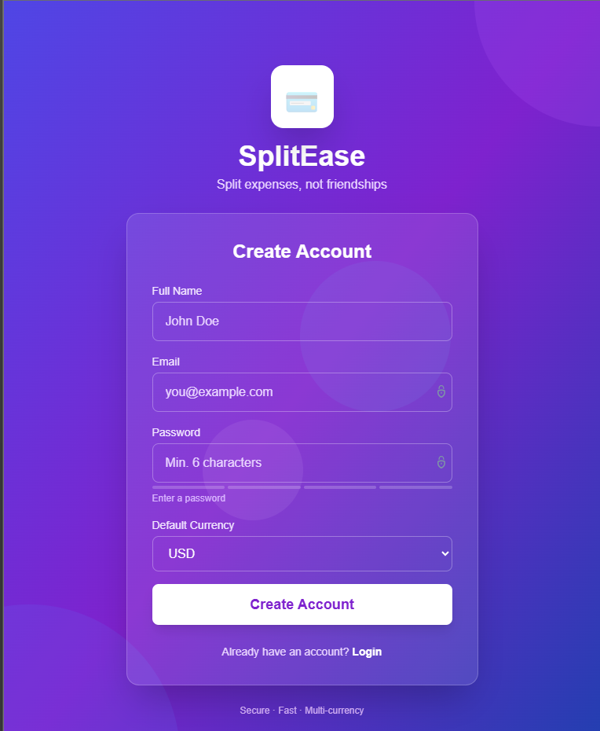

Dashboard Page
The dashboard displays all of the user's groups in a responsive grid layout with an animated gradient background and floating bubble animations. Each group card shows the group name, description, base currency badge, member avatars, and a red delete button. Hovering over a card triggers a lift and glow effect. A '+ New Group' button opens a modal for creating new groups.
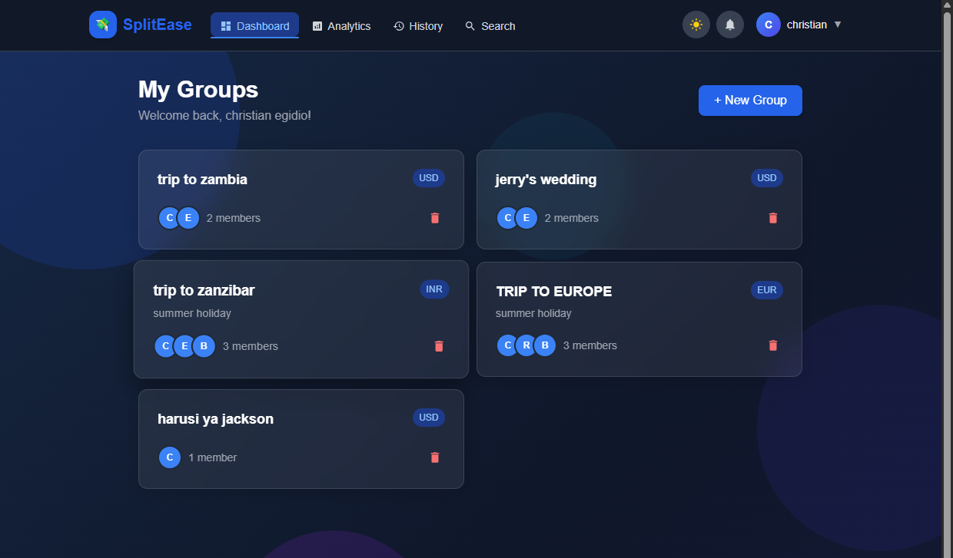

Group Detail Page
The group detail page is the most feature-rich page. It displays the group name and description, three balance cards (You are owed, You owe, Net balance) in green/red/blue, two charts side by side (Line graph for spending trend over time, Doughnut chart for spending by member), a members section with avatar chips, and a full list of expenses. Each expense card shows the description, amount with currency conversion hint, split type, individual member splits with Settled/Pending badges, and action buttons (Mark as settled / Delete).
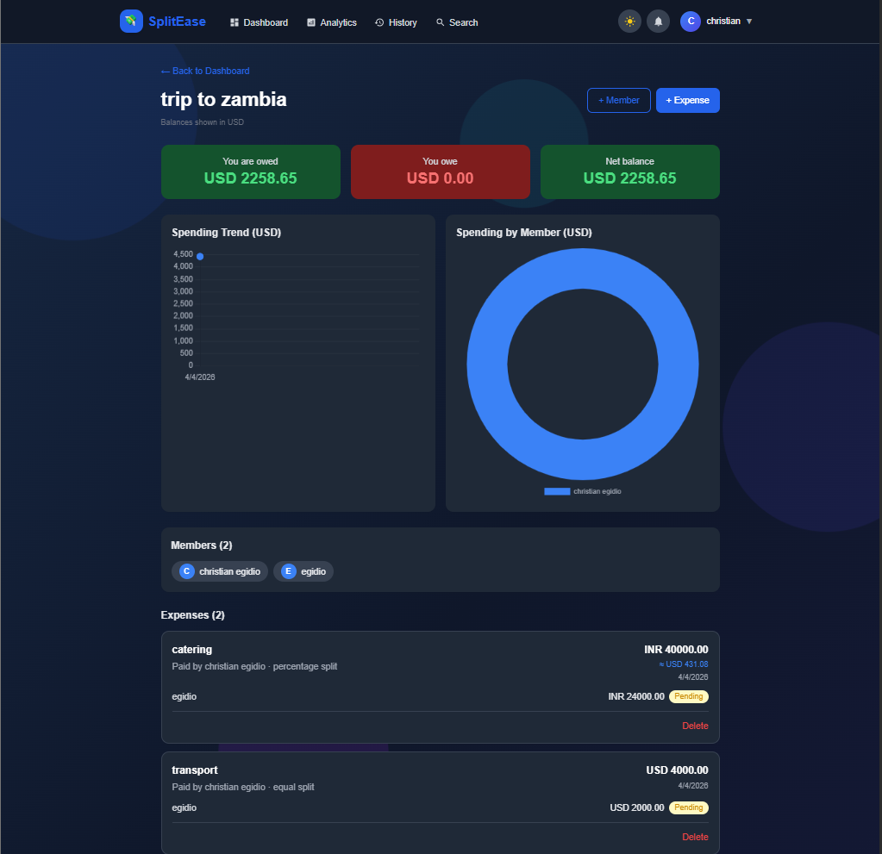

Analytics Page
The analytics page shows four stat cards (Total Spent, Groups, Expenses, Settled) with professional Material Design icons. Below are two charts: a line graph showing spending over time and a doughnut chart showing spending by group. A progress bar breakdown section animates in showing each group's spending as a percentage of the maximum.
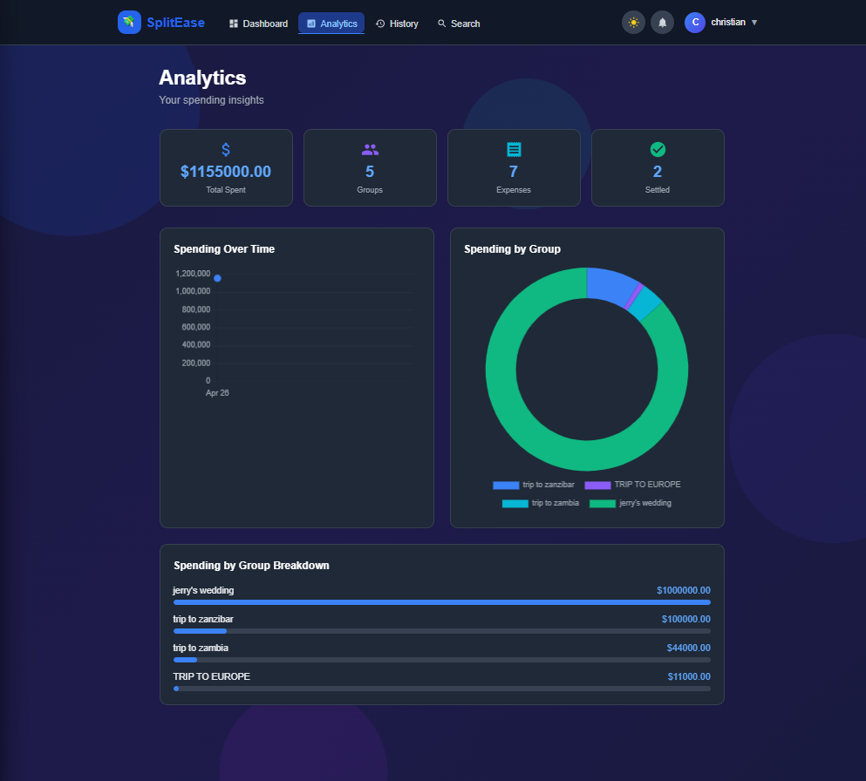

Search Page
The search page has a large search input with a search button. Results animate in as cards showing the expense description, amount, split type, group badge, and date. Clicking any result navigates to the group that contains it.
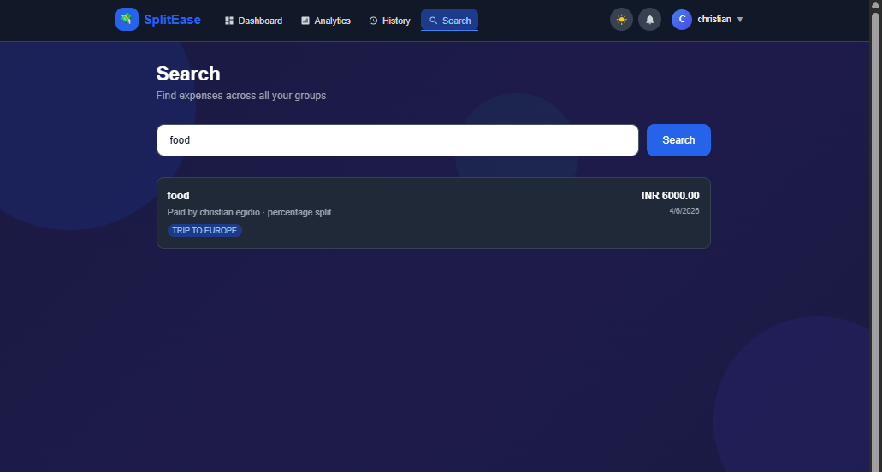

Settlement History Page
Shows all settled expenses across all groups with summary statistics (Total Settlements, Total Amount, This Month). Three filter buttons (All, I Paid, I Received) filter the results. Each settlement card shows who settled with whom, the amount, group name badge, and date.
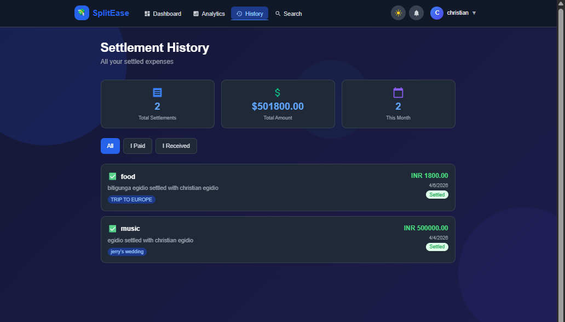

Profile Page
The profile page shows a large avatar with the user's initial, name, email, and default currency badge. Two tabs switch between Personal Info (edit name, email, currency) and Change Password (current password verification required). A Save Changes button submits updates.
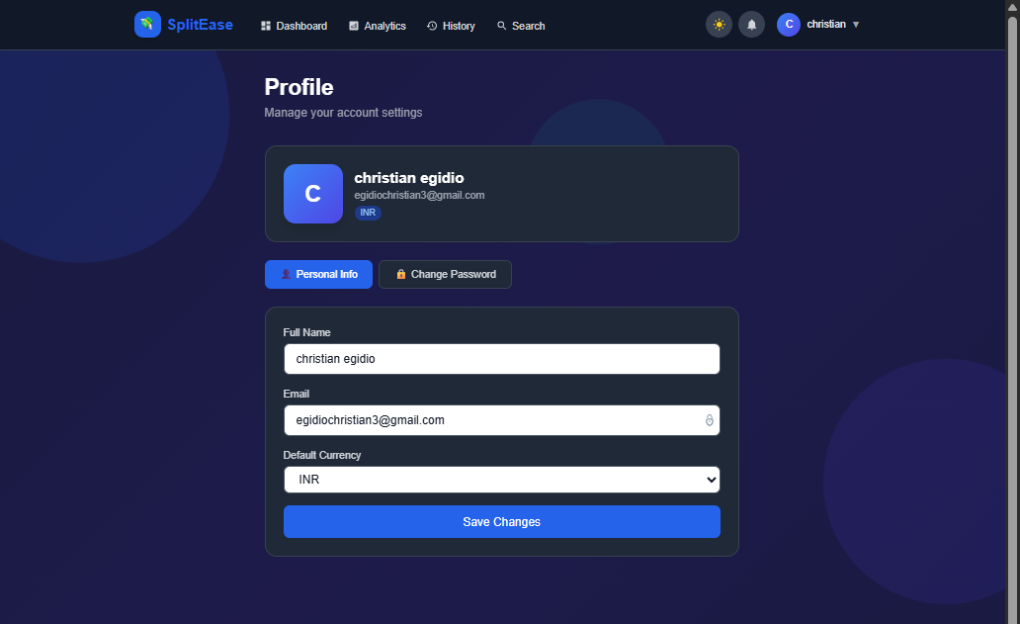

Navbar
A sticky navbar with a SplitEase logo (animated spin on hover), four navigation links with active indicators (Dashboard, Analytics, History, Search), a dark mode toggle button with sun/moon icons, a notification bell with animated ring and unread count badge, and a profile dropdown showing user name/email with links to Profile, Analytics, History, dark mode toggle, and Logout.

CONCLUSION
SplitEase successfully demonstrates the implementation of a full-stack MERN application that addresses a real-world problem. The application covers all aspects of modern web development including secure authentication, RESTful API design, database schema design, real-time communication, external API integration, and responsive animated frontend design.

The project meets all minimum requirements specified in the course prerequisites including JWT authentication, bcrypt password hashing, protected routes, full CRUD functionality, Context API state management, Tailwind CSS styling, React Router navigation, and proper error handling with toast notifications.

Beyond the minimum requirements, SplitEase incorporates several advanced features that demonstrate deeper technical understanding:

- Real-time notifications using Socket.io WebSockets
- Live multi-currency support with intelligent caching strategy
- Three different split calculation modes with a dedicated utility module
- Interactive analytics dashboard with multiple chart types
- Professional animations using Framer Motion throughout the application
- Dark mode with localStorage persistence
- Input validation on both frontend (real-time) and backend (express-validator)

Future enhancements could include M-Pesa and mobile money payment integration for the Tanzanian market, role-based access control, offline support with service workers, SMS notifications using Africa's Talking API, and a React Native mobile application leveraging the same backend.

CODE EXPLANATION VIDEO
https://drive.google.com/file/d/1S6A24fZ6kN7XmEh5gbGmLF20aF9o8mof/view?usp=sharing

PROJECT OVERVIEW VIDEO

https://drive.google.com/file/d/1CVQ8TW4aQRKayD0PcKg3pnMj625eUT2x/view?usp=sharing

GITHUB REPOSITORY LINK

https://github.com/egidiochristian3/expense-splitter

